User Interface Functionality Guide

In this section we present the functionalities we built in our application and how the user can interact with them.

In general, for all pages, we designed a navigation bar and footer bar, where the user can navigate through the pages of the website. The navigation bar shows the options for index page, breeds page, care for cats page and your favorite cat or voting page, as shown in the image below.



For the footer page we have almost the same buttons as described in the navigation page: (breeds page, care for cats page, your favorite cat page; we also added a functionality called “Contact us”, where the user can send a message to the admins of the webpage with some message. They can also subscribe to the newsletter entering their email. A successful message appears in case positive.

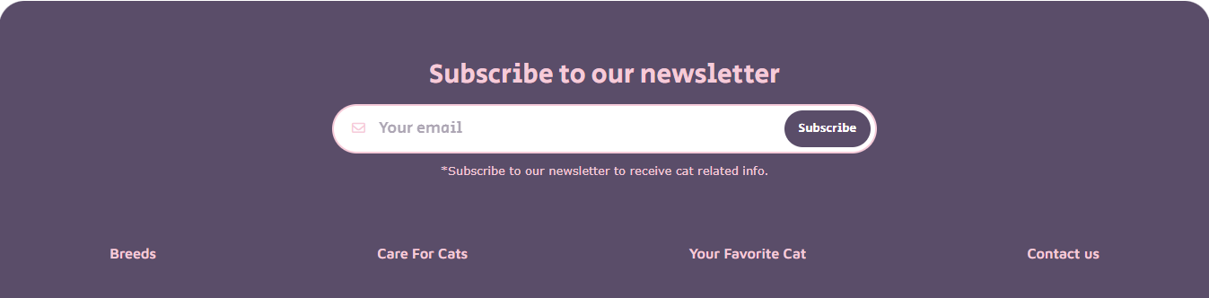

When the user clicks on the contact us button, this box below pops up in the screen, when the user has to input Name, E-mail and their Question. If successful, they receive a message confirm that the message was send.

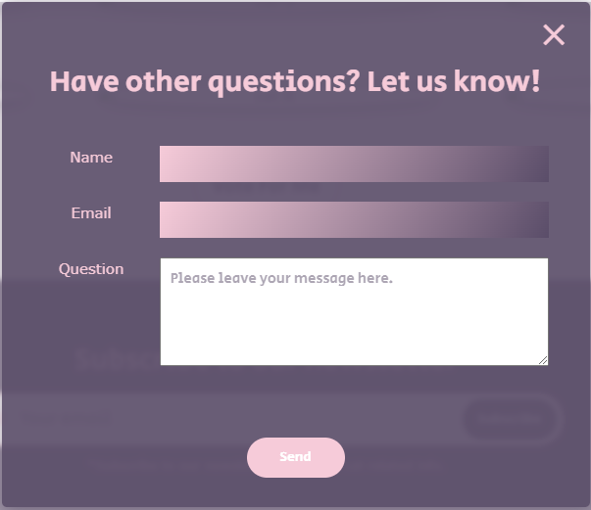

In the main content of the index page, the user can use the search bar to go directly to the breeds page with a cat name to search. He can also click in the subtitles of the care for cats section to be redirect to the care for cats page, as well as the click on the button “vote for me” will take the user to your favorite cat page.

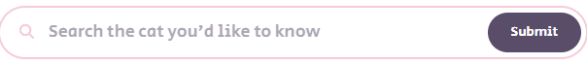

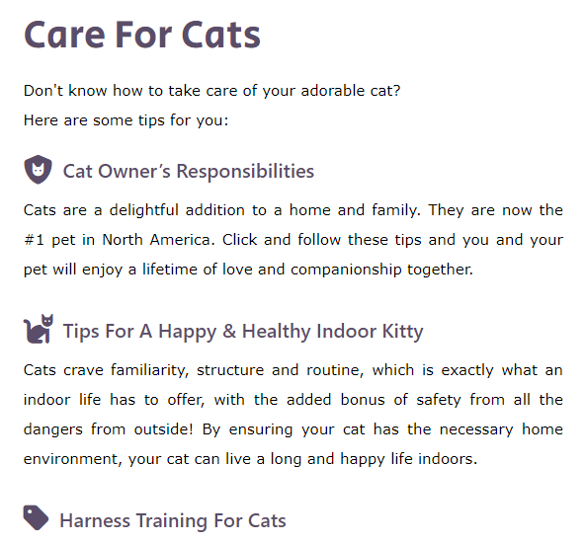

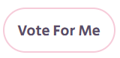

In Breeds page, there is only one functionality – besides the nav bar and footer – which is the search bar to display in the gallery only the Breeds Name included in the search of the user. The search works with the “keyup”, that means the function to return the values is executed when the user enter any value on the search bar. They do not need to click in any button to the search happen.



The Care For Cats page is a informative page, meaning that there is no functionality on the page. Its purpose is bring information about how to take care of a cat to the user.

The page “Your favorite cat” has the purpose to let the user vote up or down about the cat in the image. Every time the user access the page, it is shown a different cat randomly, hence the user can always come back to vote in new cats. This page use cookies to keep the register of the votes of the user, so they can access and see again which cat`s images they vote up or down.

